`

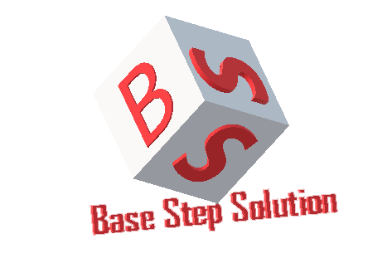

Meeting Minutes

Van Lang Admissions

# Revision Table

|  |  |  |  |
| --- | --- | --- | --- |
| Author | Date | Reason for changes | Version |
| Khoi Nguyen | 21/11/2016 | Initial Document | 1.0 |

Table of Contents

Revision Table 1

I. Purpose 3

II. Participant in meeting 3

III. Content of meeting 3

IV. To do task 4

|  |  |  |  |  |  |
| --- | --- | --- | --- | --- | --- |
| **Writer:** | Khởi Nguyễn | **Location:** | 7 Floor of Van Lang university | | |
| **Date:** | 24/10/2016 | **Start:** | 10h50 | **Finish:** | 12h |

# Purpose

* Review Process
* Discuss about incremental process

# participant in meeting

Mentor Lê Sĩ Phú

Team Capston:

* Nguyễn Thái Hiền
* Nguyễn Hoàng Anh Tài
* Đoàn Anh Minh
* Trần Xuân Hải
* Nguyễn Anh Khởi
* Nguyễn Xuân Thái Hiền

# Content of meeting

- Compare incremental original with incremental build

- How Test -> Design

- Sub-process of each process

- Update all processes

- Reading and understanding of the incremental process together

- Need test all phase

- Process always have Roles , Activities , Artifacts

# To do task

* Learn software development ( NodeJS , MongoDB , AngularJS … )
* Create Usecase
* Create Con-ops
* Create SRS

---- *** ----